Hong Kong Red Cross One-off Donation Form
6346/GD

Donor’s Information
Name | (Mr /Ms)  (Last Name) (First Name) |  | Donor No. (if applicable)
Address |  |  | Tel
Address |  |  | Fax
If the name of the receipt is different from the above, please state: |  |  | Email
Please choose preferred language for communications:  中文  English
Personal Information Collection Statement
Hong Kong Red Cross (“HKRC”) undertakes to comply with the requirements of the Personal Data (Privacy) Ordinance to ensure that personal data obtained are accurate and securely kept. To safeguard interest of our data subject, HKRC collects personal data from you for the purposes of administration, receipt issuing and other promotion activities (as defined below).  HKRC may use the personal data you provided (including your name and contact details) for the purposes of providing you with information of HKRC, donation follow up, communications & promotion activities. Your personal data may be provided to third party service provider (outside HKRC) who provides data handling for administration and marketing purposes. However, we will not use your personal data unless we have received your consent. Upon your request at any time and at no charge, we will cease to use your personal data for promotion purposes. Please contact our Donation Hotline at 2802 0016 for enquiry or any updating of your personal data. |  | Please sign at the end of this statement to indicate your agreement to such use of personal data as the left  Should you find such use of your personal data not acceptable, please indicate your objection before signing by ticking the box below.   I object to the proposed use of my personal data as stated above  Signature: ______________  Name: __________________  Date: ___________________

Donation Information
I would like to make a one-off donation to support the Hong Kong Red Cross
Donation Amount：
❑ HK$2,000 HK$1,000 HK$500 HK$300 HK$200  ____________(Other donation amount)

To save administration costs, no donation receipt is required.

Donation Method

- Direct Transfer to the Hong Kong Red Cross Accounts
HSBC 500-334149-009 Bank of China (Hong Kong) 012-806-00028173
Hang Seng Bank 388-553950-001 Bank of East Asia 015-514-10-401122-1

Please mail the original bank pay-in-slip together with this form to the Hong Kong Red Cross for a donation receipt.

- Crossed Cheque (Cheque No.: )
Please make your cheque payable to the “Hong Kong Red Cross” and mail together with this form for a donation receipt.
- Faster Payment System (FPS)
Please transfer the donation to the Hong Kong Red Cross “FPS ID” : 164279317
Please send us a screen capture of the related transaction history with your name, telephone no., postal address and donor ID(if applicable) to
crd@redcross.org.hk for the donation receipt.

❑ PayMe  Please fill in the date and time of donation on the right of this  form and send it back to the Hong Kong Red Cross for a  donation receipt | 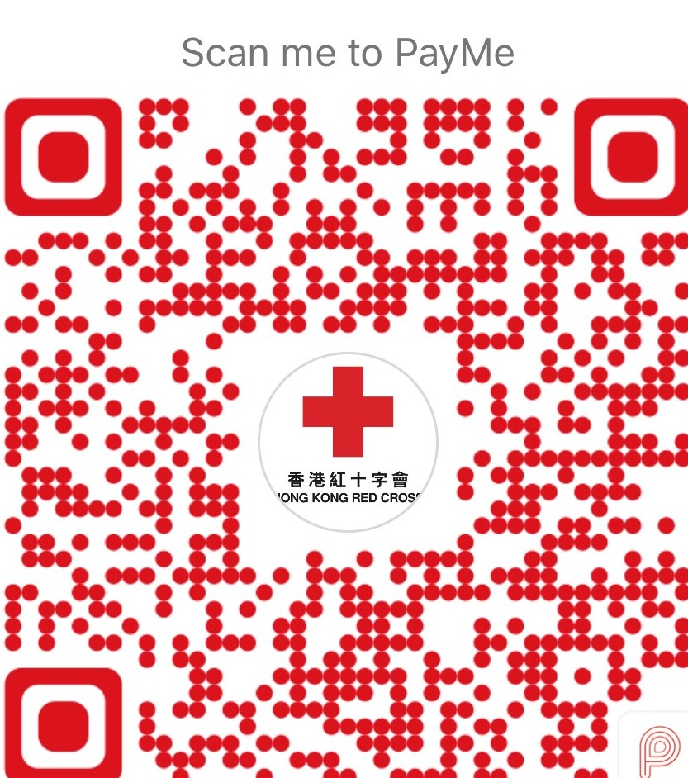  Donation date﹕_____(dd)/ _____ (mm)/ _____ (yy)  time﹕_____:_____ (hh:mm)

- 7-Eleven
Please mail the original receipt from 7-Eleven with this form to the Hong Kong Red Cross for a donation receipt.
- Donation through e-Banking

Please print out the confirmation webpage of the donation through e-Banking, and mail together with this form for a donation receipt.
- Credit Card
Credit card donation can be sent to us by mail or by fax to 2802 0017.


❑ VISA  MASTERCARD  AMERICAN EXPRESS
Cardholder’s Name |  | Cardholder’s Signature
Card No. |  | Expiry Date  (Expiry date is valid for at least two months) | Month Year

Hotline: 2802 0016 Fax: 2802 0017
Email: crd@redcross.org.hk Website: www.redcross.org.hk
Address: Hong Kong Red Cross Headquarters, 19 Hoi Ting Road, West Kowloon, Hong Kong
202104

